**VISVESVARAYA TECHNOLOGICAL UNIVERSITY**

**Jnana Sangama, Belagavi-590018, Karnataka**

A Technical Seminar Report On

**“EARTH RESISTANT CONSTRUCTION OF ADOBE BUILDING”**

Submitted in partial fulfillment of the requirements for the award of the degree of

Bachelor of Engineering

Submitted by

**LIKITH.S (1EW17CV418)**

Under the Guidance of

**Ms. USHA K N**

**Assistant Professor**

Civil Engineering, EWIT

Bengaluru-560091

DEPARTMENT OF CIVIL ENGINEERING

**EAST WEST INSTITUTE OF TECHNOLOGY** BENGALURU- 560091

**WEST INSTITUTE OF TECHNOLOGY**

Sy, No.63, Off.Magadi Road, Vishwaneedam Post, Bengaluru-560091 (Affiliated To Visvesvaraya Technological University, Belgavi)

**DEPARTMENT OF CIVIL ENGINEERING**

**CERTIFICATE**

This is to certify that the technical seminar entitled “**Earthquake Resistant Construction of Adobe Building"** carried out by **LIKITH.S bearing** **USN: 1EW17CV418, a** bonafied student of **EAST WEST INSTITUTE OF Engineering,** in partial fulfilment for the award of **Bachelor of Engineering in** **civil engineering** of the **Visvesvaraya Technological University**, Belagavi, during the year 2019-2020. The technical seminar report has been approved as it satisfies the academic requirements in respect of project work prescribed for the said degree.

|  |  |  |
| --- | --- | --- |
| Ms. USHA K N | Dr. M S Nagaraja Gupta | Dr. Channakeshavulu |
|  |  |  |
| Technical seminar guide | Head of Department | Principal |
| Dept. of Civil Engineering  EWIT, Bengaluru | Dept. of Civil Engineering  EWIT, Bengaluru | EWIT, Bengaluru |

**ACKNOWLEDGEMENT**

It is indeed a great privilege for me to present this technical seminar, I take this opportunity to thank all those who made this endeavour success.

I would like to express my deepest sense of gratitude to my technical seminar guide **Ms. USHA K N** Department of Civil Engineering for her encouragement, innumerable suggestions, right from the beginning and throughout the technical seminar.

It gives me immense pleasure to thank our Professor and Head of Department **Dr. M S NAGARAJA GUPTHA** for his constant support and encouragement.

I would like to express my thanks to the Principal **DR. CHANNAKESHAVULU** for his encouragement that motivated me for the successful completion of Technical seminar.

Also, I would like to profoundly thank **EAST WEST INSTITUTE OF TECHNOLOGY** for providing such a healthy environment for the successful completion of Project work.

Last, but not the least, I would here by acknowledge and thank my parents who have been a source of inspiration and also instrumental in the successful completion of the technical seminar.

**CONTENTS**

1. INTRODUCTION
2. LITERATURE REVIEW
3. ADVANTAGES
4. DISADVANTAGES
5. APPLICATIONS
6. CONCLUSION
7. REFERENCE

**+1.0: Introduction**

**1.1: DESCRIPTION OF ADOBE.**

Adobe are one of the types of masonry units. Adobe mud blocks are one of the oldest and most widely used building materials. These are sun dried bricks made out of locally available soil. Which is generally sandy with adequate amounts of clay adobe is a low cost, readily available construction materials manufactured by local communities. These structures are generally self made as construction practice is simpler does not require additional energy consumption. Skilled technicians are usually not involved in this type of construction and hence it is also named as “non-engineered construction”.

Use of Adobe dates back to 8000B.C and its use is very common in some of the worlds most hazard prone regions, traditionally across latin America, Africa, Indian Sub-continent and in other parts of Asia, Europe and middle cast. These have been shown as shaded in fig 1.0

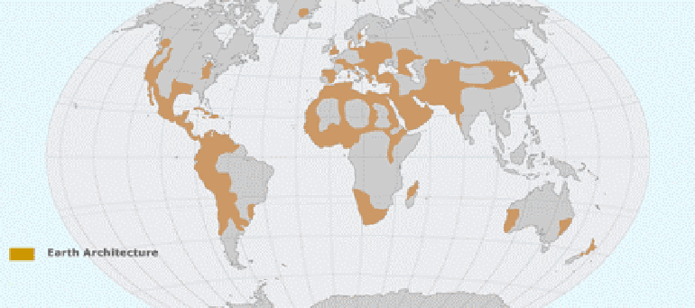 Fig. 1.0- Adobe buildings in different countries.

**1.2- Objective**

The main objective of this study is

(i) To study the failure patterns, earthquake performance and seismic improvement of new adobe constructions.

(ii) Seismic strengthening of existing adobe buildings.

Constituents / Soil Selection for Adobe

Adobe is a composite material made of clay mixed with water and organic mater such as straw/ dung. Soil composition is clay and sand. Straw helps in binding the brick together and dung helps to reel insects.

Adobe bricks are made in open frame 25cm by 36cm / as in any continent size. The mixture is molded by frame and then frame is removed quickly after drying for few hours, bricks are turned on edge to finish drying. Slow shade drying reduces cracks.

**1.3- Types of Adobe**

Adobe blocks are classified in 2 ways

(i) Classification based on type of material

a) Plain Adobe b) Stabilized adobe

(ii) Classification based on process of adobe making

a) Sliced adobe b) moulded adobe

Soil will be kneaded before making bricks which leads to thorough working of clay and development of homogenized structure with clay particles coating silt and sand.

Also, adobe shrinks in volume as moisture escapes which leads to natural densification of soil by capillary action. The density resulting from this drying is not inferior to one obtained by machine pressing. Thus it gives good performance.

**1.4- Advantages of adobe buildings**

(i) Adobe bricks are fire proof, durable, non toxic and provides sufficient thermal mass to buildings. Adobe walls serve as a significant heat reservoir due to inherent thermal properties in the massive walls of adobe construction. In direct areas having hot days and cool nights, high thermal mss of adobe levels out heat transfer through wall to living space. Massive walls require relatively large input of heat from sand surrounding air before they warm through to the interior and being to transfer heat. After sun sets and temperature drops, warm walls still continue to transfer heat to interior force several hours.

Thus well planned adobe building with wall of appropriate thickness is very effective in controlling temperature. In additional to this, external adobe walls can be covered with glass to increase heat collection.

(ii) Sound transmission levels through walls is low.

(iii) This is highly suitable to owner builders is no costly equipments are necessary.

(iv) Adobe system allows individual units to shrink before they are placed in wall. Which reduces risk of cracking and shrinkage.

(v) Adobe bricks have good water resistance because of nature of clay.

**2.0- Earth quake performance of adobe buildings.**

**2.1- Introduction**

Adobe structure are vulnerable to defects of natural phenomena such earthquake, rain floods.

Earthquakes cause most of loss of life that occurs due to collapse of buildings constructed in traditional materials which are not particularly engineered to be earthquake resistant.

These adobe buildings are built by traditional practices without any detailed structural analysis. This deficiency of design to contract the stresses developed combined with poor quality construction materials increases the extent of damage.

Traditional adobe buildings responded very damage or collapse causing significant loss of life and property. These seismic deficiencies are mainly caused due to

a) Heavy weight of structure.

b) Low Strength

c) Brittle behavior.

**2.2- Typical failures.**

During strong earth quakes, due to heavy weight of the structures, they develop high levels of seismic forces which they are unable to resist. This leads to abrupt failure of the structure. Figure 4 shows some typical failure patterns of Adobe buildings during an Earth quake.

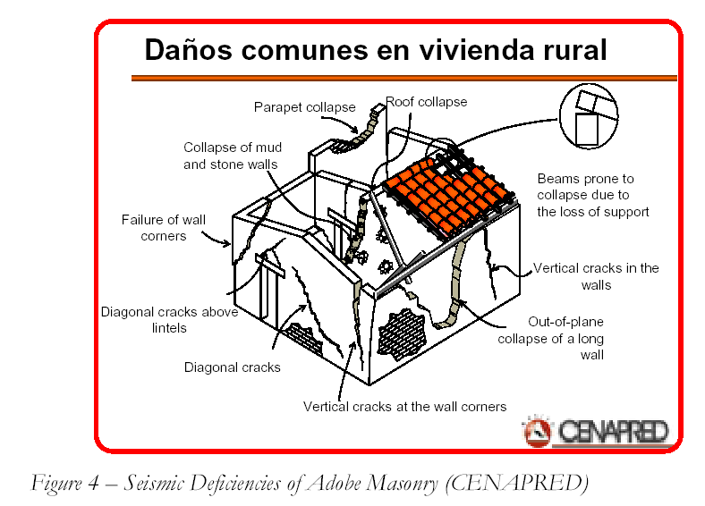

a) Severe cracking and disintegration of walls.

b) Separation of walls at corners.

c) Separation of roofs from walls.

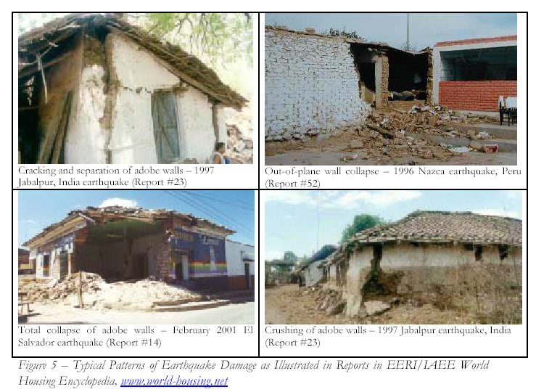**2.3 – Seismic deficiencies of adobe masonry**

(i) Vertical cracks at wall corners.

(ii) Diagonal cracks above lintel

(iii) Vertical cracks in walls

(iv) Out of plane failure of long walls.

(v) Collapse of roof and parapet

(vi) Failure of beams due to loss of support.

**(i) Vertical cracks at corners.**

Large relative displacement between orthogonal walls occurs. Shear walls have low response and transverse walls have little resistance to bending resulting in large displacement. This large displacement between shear and transverse walls induce stresses at connection of walls. Thus cracking occurs when material strength exceeds either in shear hearing.

**(ii) Over tuning of upper part of wall panel.**

Out of plane seismic forces induces bending about horizontal and vertical axis. Bending about Vertical axis causes splitting causing vertical cracks in upper part of walls. These vertical cracks reduce resistance to bending about horizontal axis in panel which leads to over turning.

**(iii) Diagonal / inclined cracking in walls.**

Out of plane deformation due to bending causes bulging which generates ‘x’ pattern cracking very large in plane shear forces. Which generates tensile stress at 450 C causes single direction inclined cracking

**(iv) Dislocation of corner**

Lack of fixity at corners allows greater out of plane displacement of panels generating pounding impact with orthogonal wall. Top of wall has greater displacement which causes greater pounding impact thus inducing greater stress leading to failure.

**(v) Separation of roof from wall.**

When there is a difference in stiffness of wall and roof, this type of failure takes palace. This is characterized by continuous horizontal cracking occurring between roof and wall.

**3.0- Improved Earth Quake Resistance of Adobe Buildings**

**3.1- Introduction**

In new of continued used of such buildings seismic areas. It is very much essential to introduce earth quake resistant features in the construction. Observation of structural performances of these buildings during an earthquake helps us in identifying the aspects for failures. Based on research and field applications, key factors for improved seismic performance of adobe construction are recommended;

**3.2- Different techniques of improving Earth quake resistance of adobe buildings.**

**(i) Laying a good foundation**

Adobe buildings SHOULD be built on leveled ground, at least 1 meter away from the edge of slopes, more if slope is steep and at least 3 meters from retaining walls or steep banks (Fig.6.0)





Adobe buildings **SHOULD NOT** Adobe buildings **SHOULD NOT** Adobe buildings **SHOULD NOT**

be built against a slope where be built near clif f s where they be built near steep slopes where.

soil pressure may cause building might slide off due to land slides falling rocks and debris may

collapse. damage the house

**Figure 6.0**

Every seismic-resistant adobe building needs a solid foundation that is well connected to the walls. Reinforced monolithic concrete foundations are best. If fired brick or rubble stone foundations are used, add a reinforced concrete beam on the top of the foundation. The foundation should extend 40cm below the ground for stability and ideally 50cm above the ground to protect walls from rain water damage and ensure that adobe bricks remain above the snow blanket in the winter. The building must be connected to the foundation so that it does not slip off. First embed large rocks in the foundation so that they project up to the height of one adobe brick. Then construct the adobe wall to fit bricks snuggly against the embedded rocks using full or half size bricks. A damp-proof course will prevent rising moisture from damaging the walls over time. Bitumen and ruberoid glues are commonly used, but these can be slippery. A thin layer of cement-sand (1:2) provides a good non-slippery damp-proof course.(Fig.7.0)

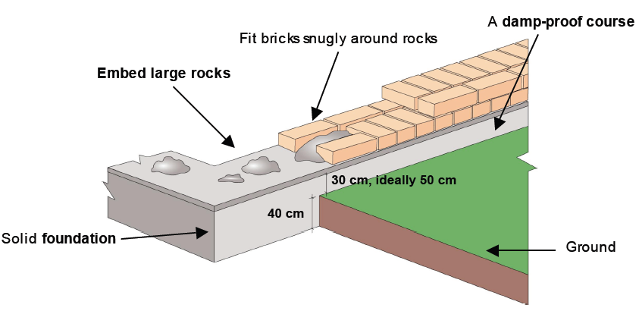

**.**

**(Figure 7.0)**

**(ii) Adobe Block Composition & Quality of construction.**

Characteristics of Soil have great influence on strength of adobe masonry.

Clay is the most important component of soil that provides dry strength and causes drying and shrinkage in soil. Some of the field tests conducted are as below.

**(a) Dry strength test on clay**

Make at least 3 mud balls of about 2cm dia from soil. After day crush each ball between thumb and index finger. IF none crushes, soil contains enough clay to be used for construction provided micro cracking is controlled. If it gets crushed, it should be discarded.

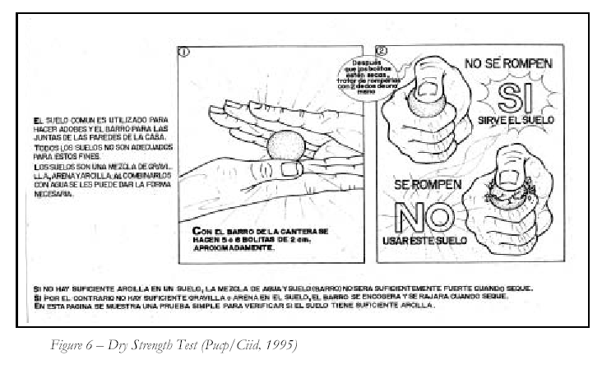

**(b) Roll test :** Make a little mud roll and roll it using both hands. IF unbroken length of roll is between 5-15 cm, so it is adequate for construction if it breaks within 5cm, it should be discarded. If it is greater than 15cm, sand should be added.

**(c) micro cracking** caused due to drying shrinkage should be controlled should controlled to obtain strong adobe masonry. To verify the amount of cracking, micro cracking control test is performed by making 2 or more adobe sandwiches. After 48 hours of shade drying, mortar between sand witches is examined. If it does not show visible cracking, soil is adequate for adobe construction. Otherwise coarse sand should be added as an additive to control micro-cracking.

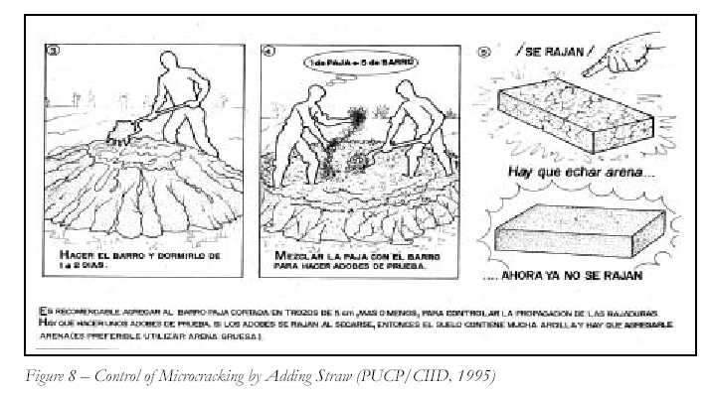

**(d) Additives :** Straw, coarse sand are used as additives to control micro cracking in order to improve the strength of masonry.

**(e) construction :** Quality of workmanship plays an important role in obtaining strong adobe masonry, foundation should be made of medium – large stones joined with mud mortar.

**(ii) robust Layout**

One of the essential principles of earth quake resistant adobe buildings is to use a rectangular / box type layout. Some of the key recommendations are;

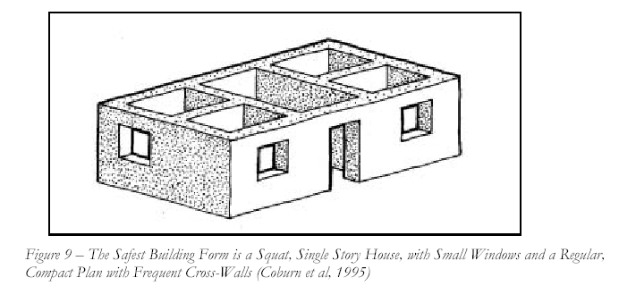a) Build only one Storey.

b) Use insulated light weight roof instead of heavy compacted earth roof.

c) Arrange wall layout to provide mutual support by means of cross walls and intersecting walls at regular intervals.

d) Opening in the wall and should be small.

e) Building should be on a firm foundation walls are the main load bearing elements.

A number of recommendations regarding wall construction has been made.

Height of wall should not be greater than 8 times its thickness.

Unsupported length of wall between cross walls should not exceed 10 times wall thickness.

Width of opening should not exceed 1.2m or 1/3 the wall length.

Distance between outside corner and opening should not be less than 1.2m.

For longer wall length , intermediate vertical buttresses should be provided.

|  |  |  |
| --- | --- | --- |
| **Table 1. Estimated Seismic Effects with Change in Wall Height-to-Thickness Ratio, SL** | | |
| **Relative Wall Thickness** | < 4 | **Overturning unlikely** |
| **Thick** | 4 - 6 | Overturning difficult; typical of historic buildings in California |
| **Moderate** | 6 - 9 | Some inherent stability but susceptible to overturning during large ground motions; simple retrofit measures can stablize. |
| **Thin** | 9 - 12 | Likely to be unstable; requires invasive retrofitting methods to stablize |
| **Very thin** | > 12 | Unstable; difficult to stablize |

**(iv) Improved building technologies**

**(a) Use of horizontal and vertical reinforcement.**

Reinforcement can be made of any material such as bamboo, cane, rope, timber or reeds.

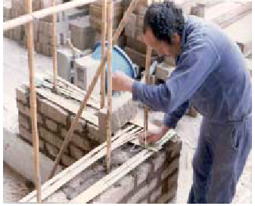Vertical reinforcement helps to the wall to foundation and to the ring beam and thus restrains out of plane bending and in-plane shear.

Horizontal reinforcement’s helps to transmit bending and inertia forces in transverse walls to supporting shear walls in between the adjoining walls and helps in minimizing vertical crack propagation.

Both these reinforcements then should be bed together and to other structural components by means of nylon strings. Which provides a stable matrix. An illustration of cane reinforcement for adobe wall is as shown

Shaking table test is conducted for testing the strength of adobe buildings. In this test, models built on a concrete platform. Testing consists of slowly tilting the platform and measuring the tilt angle of collapse. Lateral components of weight of the model will be them used to find max seismic force.

**Case Study;**

In 1992, 8 full sized models of one room single storey was tested on shaking lable. Results have shown that Horizontal and vertical cane reinforcement combined with sold ring beam prevents separation of walls in corners due to severe earthquake and thus can maintain structural integrity.

**(b) Buttresses and pilasters**

Buttress are structures built against a counterfeit /projecting from wall to reinforce the wall or to severe as a support.

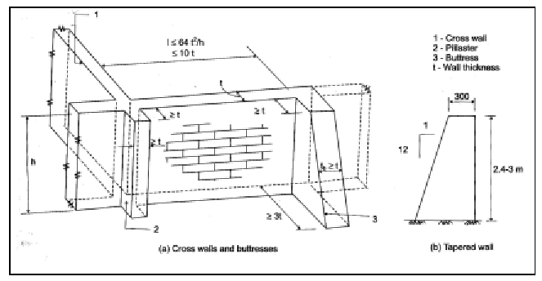

Pilasters are slightly projecting rectangular columns from walls They are enlarged portion of masonry wall to provide support for roof and lateral roads. Its projection from the wall is 1/3 its width.

They are architectural members right angled in plan corresponding to column having capital shaft and base. Intermediate pilasters offer resistance to vertical cracking. Over tuning bulging etc. corner pilasters provide resistance to out of plane response. Use of buttresses and pilasters in critical pacts of a structure increases stability and stress –resistance. They enhance the interlocking of corner bricks. Buttresses act as counter supports that may prevent inward / outward over turning of the wall. Sections where buttresses and pilasters can be used are.

* Corners where pilasters take form of overlapped walls.
* Intermediate locations in long walls Where buttresses take form of perpendicular bracing walls.

**Case Study :**

Use of buttresses and pilasters in adobe construction has been reported in EI Salvador.

Some of the recommendations fro dimensions of buttresses and pilasters are as shown below.

In T- junctions, collar beams should cover buttresses.

**(c) Ring Beams**

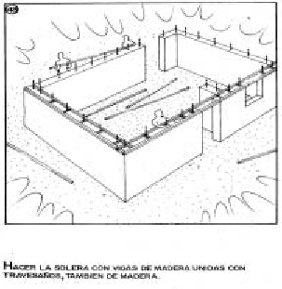Ring Beams are also called as collar beam, seismic beam or tie beam. Ring beam is one which ties the walls in a box like structure. It is one of the essential components of earth quake resistance for load bearing construction. For good seismic performance, it should b provided continuous like a loop or belt.

Ring beam must be strong, continuous and we tied to the walls and it should receive and support the roof. IT can be made of either concrete or timber. It is continuous horizontal beam that encircles a building. IT allows uniform distribution of roof load onto the walls thus reducing zone so of high stress distribution. Its effectiveness increases with wall – ring beam and ring beam – roof connection. Strong connection between wall and ring beam is achieved attachment to vertical reinforcement.

**(d) Roofing :**

A lighter roof attracts less seismic forces. Roof beams should be rested on longitudinal wooden elements for load distribution on walls and their position should be located to avoid them over openings. Otherwise lintel should be reinforced.

**(e) Building Configuration**

Building should be regular and symmetrical (Asymmetry 🡪 torsion Stress)

* Building height should restricted to 1 storey.
* Length of building should not be greater than 3 times width.

**3.3- I.S.CODE PROVISION**

IS-13827: 1993 has given certain general consideration for improving earthquake resistance of adobe boils.

* Dry clay blocks are hard and strong in compression and shear. Water penetration makes it soft and weak leading to strength reduction upto 80-90% hence once built, ingress of moisture in walls should be prevented.
* Earthquake force is a function of mass, Hence building should be as light as possible. Roofs in particular should be light weight.
* Height : 2 storeyed houses have shown high vulnerability to earth quakes in zones. Hence only one storey construction should be adopted in zone 4 and 5.
* For better earthquake resistance, building should have rectangular plan and it should be symmetrical.

**3.4- Costs :**

Adobe is a low cost readily available construction material. Typical cost of new adobe house in India is about US $11 / m2.

**3.5- Case study**

1) Building research institute, Germany has done extensive survey into properties of earth, sand and bamboo and has implemented low –cost housing using innovative building techniques in India. Chile, While shows that it is possible to build E.g. Resistant walls from earth, sand and bamboo.

2) A Census conducted by Salvadoran government states that after earthquake of January 13, 2001 (7.6 on Richter scale) adobe houses were not worse affected than other types of construction.

**3.6- Seismic Strengthening of existing adobe buildings**

An external reinforcement can be provided to delay the collapse of the structure during an earthquake. Different reinforcement materials were tested like ½ inch rope, wooden boards and welded mesh.

Dynamic tests demonstrated that best solution for existing adobe houses is to provide reinforcement consisting of welded mesh of 1mm wires spaced as ¾ inch. Nailed with metallic caps against the adobe. Mesh should be placed in horizontal and vertical strips stimulating beams and columns and is covered with cement and sand mortar. This proved to be highly effective in delaying the collapse of the structure.

During an earthquake in few existing adobe house that was externally reinforced with welded mesh covered by cement sand mortar withstood the seismic force without any damage. Whereas, houses with no reinforcement were severely damaged and collapsed.



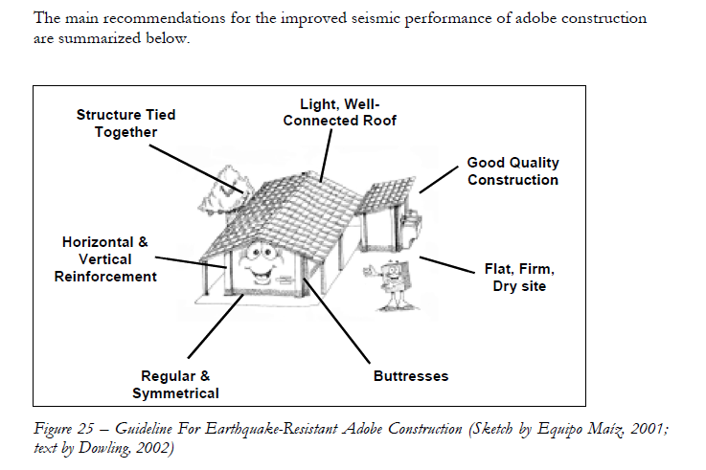

**4.0- Conclusion**

In this study on earth quake resistant adobe buildings a detailed discussion on the following have been dealt.

(i) Typical failure patterns of adobe masonry

(ii) Seismic deficiencies of adobe masonry

(iii) Improved earth quake resistance of adobe building

(iv) Seismic strengthening of existing adobe building **4.1- REFERENCES**

1) Bariola, J., Blondet, M., Torrealva, D., and Vargas, J. (1986) Comportamiento Dinámicode Viviendas de Adobe (Dynamic Behavior of Adobe Dwellings) VI Congreso Nacionalde Ingeniería Civil, Cajamarca, Perú.

2) Blondet, M., Torrelva, D., and Villa Garcia, G. (2002). Adobe in Peru: Tradition, Research and Future. Modern Earth Building 2002 – International Conference and Fair,Berlin, Germany.

3) CENAPRED, Métodos de Refuerzo para la Vivienda Rural de Autoconstrucción

(Reinforcement Methods for Selfconstruction of Rural Housing), México City, México

4) Coburn, A., Hughes, R., Pomonis, A., Spence, R. (1995). Technical Principles

of Building for Safety. Intermediate Technology Publications, London, UK.

5) CTAR/COPASA, GTZ, PUCP, SENCICO (2002) Terremoto? ¡Mi casa si resiste!

(Earthquake? My house withstands!), Arequipa, Perú. Regular & Symmetrical Horizontal & Vertical Reinforcement Buttresses Flat, Firm, Dry site Good Quality Construction Light, Well- Connected Roof Structure Tied Together 24

6) De Sensi, B, 2003, Terracruda, La Diffusione Dell’architettura Di Terra (Soil, Dissemination of Earth Architecture), www.terracruda.com/architetturadiffusione.htm).

7) Dowling, D.M. (2002). Improved Adobe in El Salvador. Powerpoint Presentation to EERI, Oakland, CA.

8) Dowling, D.M., (forthcoming). Adobe Housing in El Salvador: Earthquake Performance and Seismic Improvement, Geological Society of America Special Paper on Natural Hazards in El Salvador.

9) EERI (2003). World Housing Encyclopedia. Earthquake Engineering Research Institute,Oakland, CA http://www.world-housing.net/

10) Equipo Maíz (2001). La Casa de Adobe Sismorresistente (Earthquake-Resistant

Adobe House). Asociación Equipo Maíz, El Salvador, 91p.

11) Houben, H. and Guillaud, H. (1994). Earth Construction – A Comprehensive

Guide. ITDG Publishing, London, UK.

12) IAEE (1986). Guidelines for Earthquake-Resistant Non-Engineered

Construction.International Association for Earthquake Engineering, Tokyo, Japan.

http://www.nicee.org/NICEE/Manuals/iaee/iaeemanual_1.html

13) PUCP/CIID (1995). Nuevas Casas Resistentes De Adobe. (New Earthquake-Resistant Adobe Houses) Pontificia Universidad Católica del Peru, Centro Internacional de Investigacion Para el Desarrolo (CIID), Lima, Peru.

14) RESESCO (1997). Reglamento Para La Seguridad Estructural de las Construcciones:Folleto Complementario Adobe (Regulations for the Structural Safety of Construction : Complementary Brochure Adobe). Asociación Salvadoreña de Ingenieros y Arquitectos, Ministerio de Obras Publicas, El Salvador, 36 p.

15) USAID, Peru Earthquake Fact Sheet #6, FY 2001,

http://www.reliefweb.int/w/rwb.nsf/vLND

16) USAID, El Salvador Earthquakes January 13 and February 13, 2001, Consolidated Data by Department, http://www.releifweb.in/w/map.nsf/wByCLatest

17) Vargas, J., Bariola, J., and Blondet, M. (1984). Seismic Strength of Adobe Masonry. Summary of a research project sponsored by the US Agency for International Development (AID), Lima, Peru.

18) Zegarra L., Quiun D., San Bartlomé A., Gisecke A. (1997). Reforzamiento de Viviendas de Adobe Existentes. 1era Parte: Ensayos Sísmicos de Muros ‘U’ (Reinforcement of Existing Adobe Houses. 1st Part: Seismic Tests of “U” Shaped Walls), Summary of a research project sponsored by CERESIS-GTZ-PUCP, XI CONIC, Trujillo, Perú.